P1

import java.util.\*;

public class Main

{

public static void main(String[] args)

{

Scanner sc=new Scanner(System.in);

System.out.println("Enter the number");

int n=sc.nextInt();

int i,j,c=0;

double sum=0;

int m=n;

while(m>0)

{

m=m/10;

c++;

}

for(i=n;i>0;i=i/10)

{

sum=sum+Math.pow((i%10),c);

c--;

}

if(sum==n)

{

System.out.println("Number is disarium");

}

else

{

System.out.println("Not a disarium number");

}

}

}

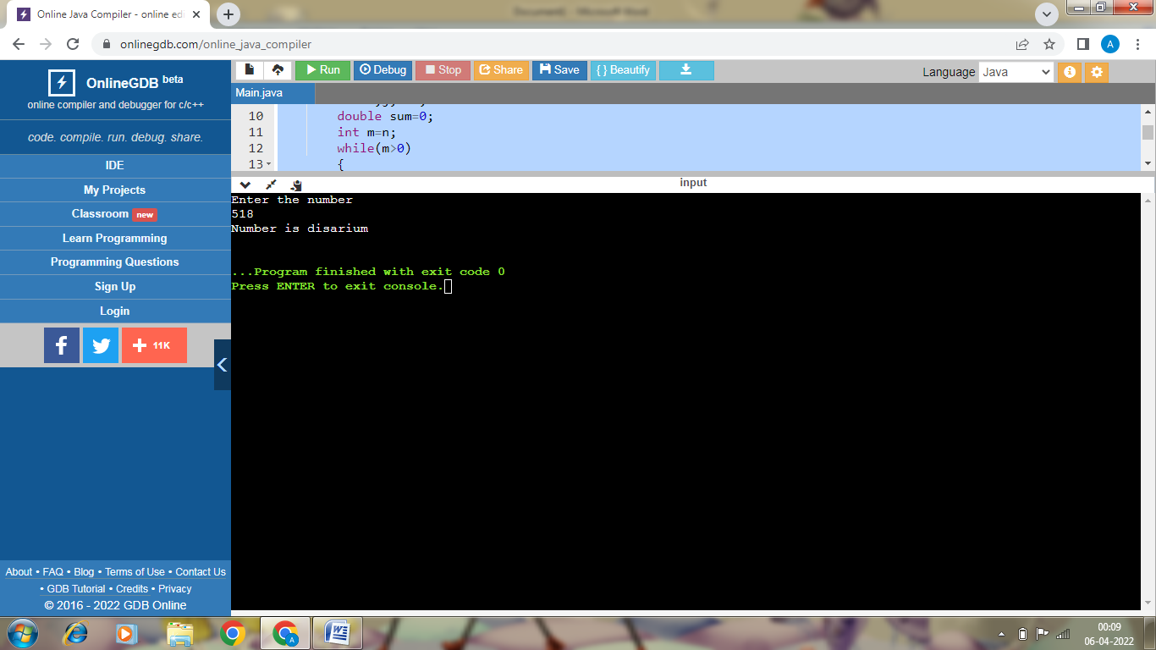

P2

import java.util.\*;

public class Main

{

public static void main(String[] args)

{

Scanner sc=new Scanner(System.in);

System.out.println("Enter the number");

int n=sc.nextInt();

int i,j,c=0;

boolean f=true;

for(i=2;i<=n/2;i++)

{

if(n%i==0)

{

break;

}

}

if(i==n/2+1)

{

System.out.println("Not a composite number");

}

else

{

System.out.println("Composite number");

}

}

}

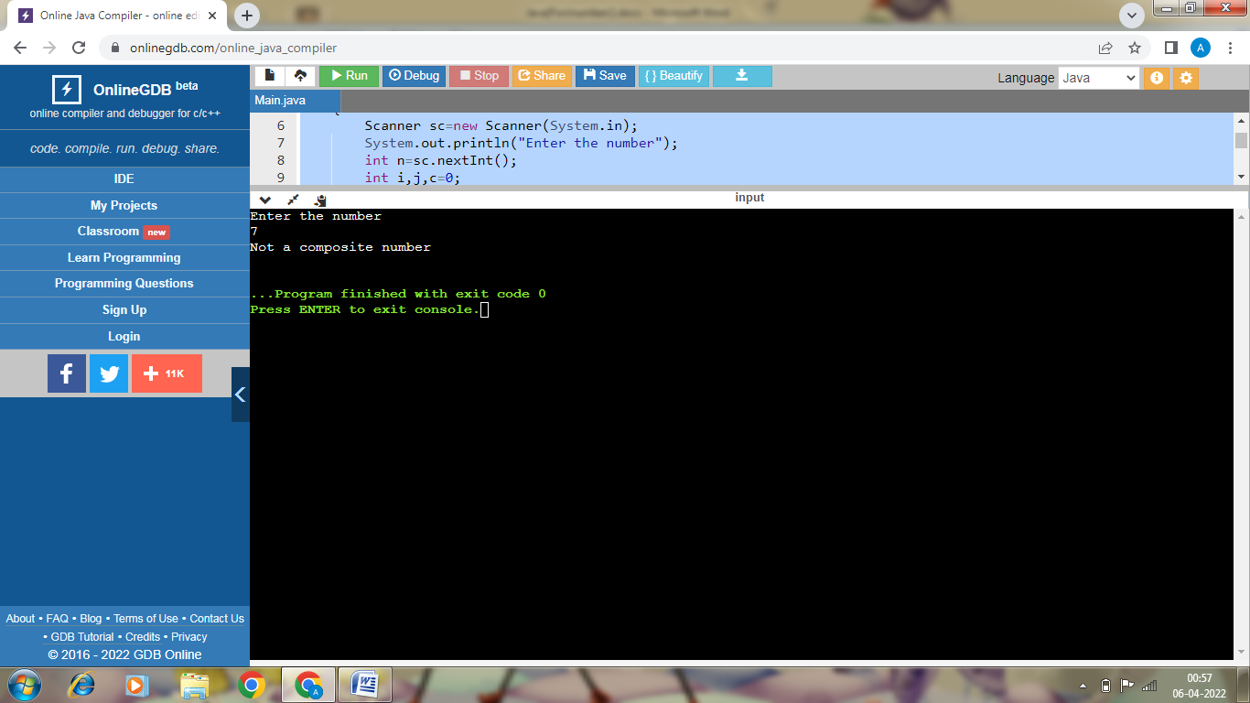

P3

import java.util.\*;

public class Main

{

public static void main(String[] args)

{

Scanner sc=new Scanner(System.in);

System.out.println("Enter the number");

int n=sc.nextInt();

int i,j,d,c=0;

double sum=0;

boolean f=true;

for(i=n;i>0;i=i/2)

{

sum=sum+Math.pow(10,c)\*(i%2);

c+=1;

}

System.out.println("Binary number is "+sum);

}

}

import java.util.\*;

public class Main

{

public static void main(String[] args)

{

Scanner sc=new Scanner(System.in);

System.out.println("Enter the number");

int n=sc.nextInt();

int i,j,c=0,d=0;

double sum=0;

boolean f=true;

for(i=n;i>0;i=i/2)

{

sum=sum+Math.pow(10,c)\*(i%2);

c+=1;

}

for(i=(int)sum;i>0;i=i/10)

{

if((i%10)%2==1)

{

d++;

}

}

if(d%2==0)

{

System.out.println("evil number");

}

else

{

System.out.println("Not evil number");

}

}

}

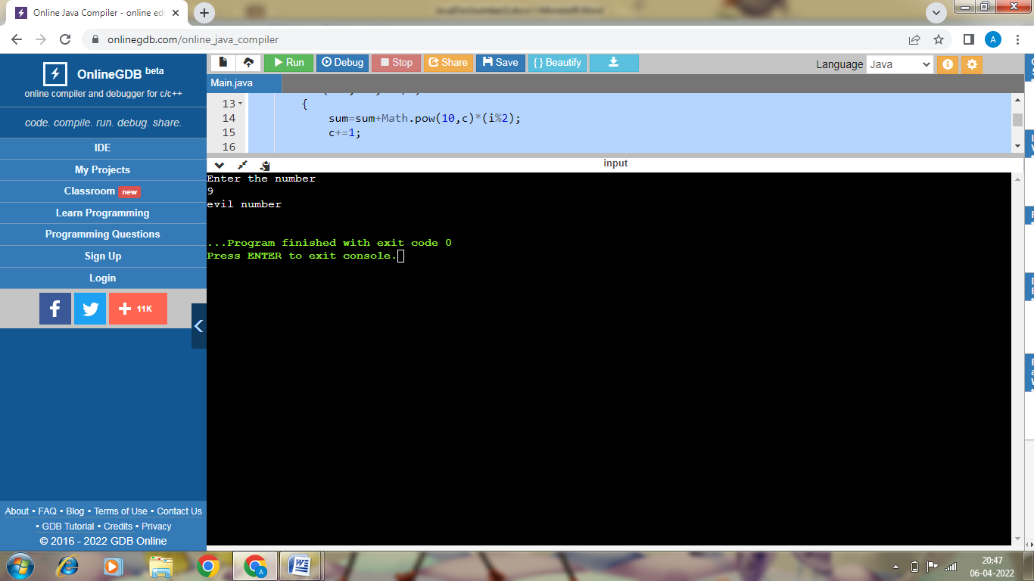

P4

import java.util.\*;

public class Main

{

public static void main(String[] args)

{

Scanner sc=new Scanner(System.in);

System.out.println("Enter the number");

int n=sc.nextInt();

int i,j,c=0,d=0;

double sum=0;

boolean f=true;

for(i=1;i<=n/2;i++)

{

if((Math.pow(i,2)==n))

{

d=1;

break;

}

}

if(d==1)

{

System.out.println("Perfect Square");

}

else

{

System.out.println("Not a perfect square");

}

}

}

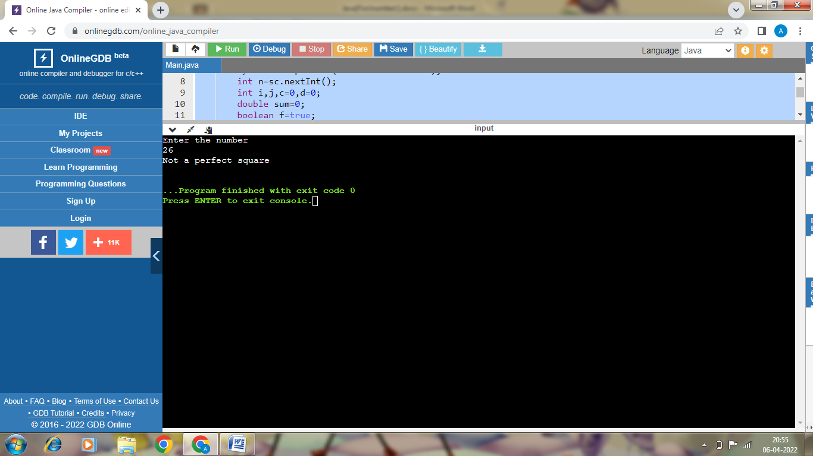

P5

import java.util.\*;

public class Main

{

public static void main(String[] args)

{

Scanner sc=new Scanner(System.in);

System.out.println("Enter the number");

int n=sc.nextInt();

int i,j,c=0,d;

double sum=0;

boolean f=true;

for(i=1;i<=n/2;i++)

{

if((Math.pow(i,2)>=n))

{

for(d=i+1;d<=(i+5);d++)

{

System.out.println(Math.pow(d,2));

}

break;

}

}

}

}

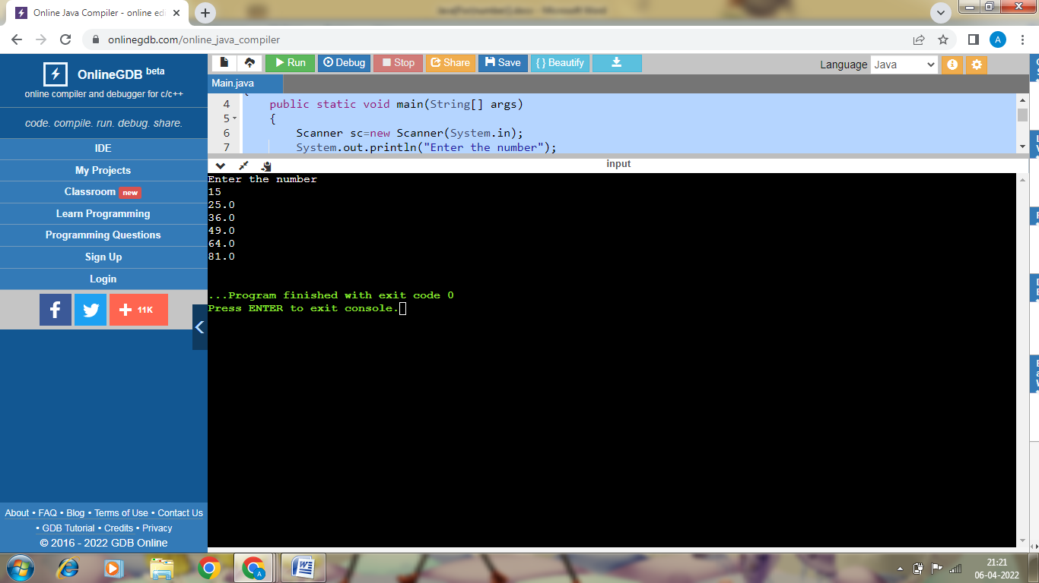

P6

import java.util.\*;

public class Main

{

public static void main(String[] args)

{

int i,j,c=0,d;

double sum=0;

Scanner sc=new Scanner(System.in);

System.out.println("Enter number");

int n=sc.nextInt();

d=n;

while(d>0)

{

d=d/10;

c++;

}

for(i=n;i>0;i=i/10)

{

sum=sum+Math.pow(i%10,c);

}

if(n==sum)

{

System.out.println("Armstrong number");

}

else

{

System.out.println("Not Armstrong number");

}

}

}

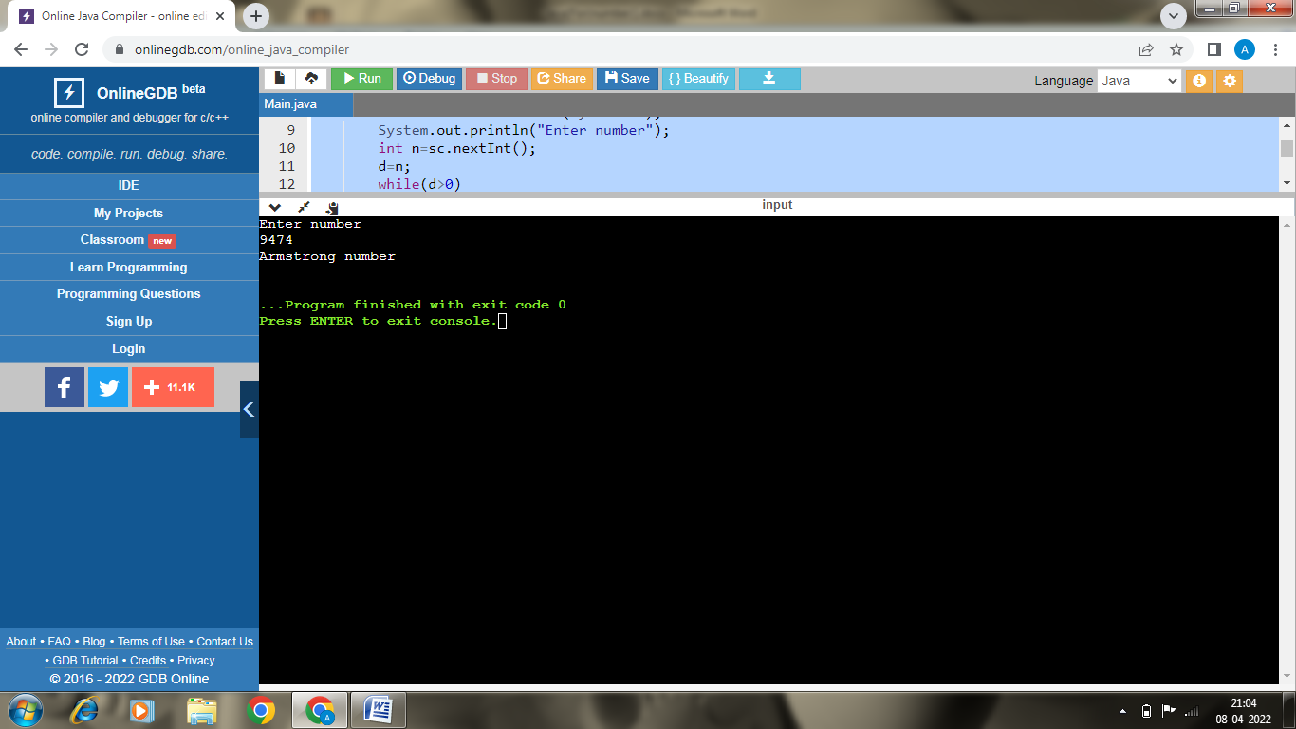

P7

P11

import java.util.\*;

public class Main

{

public static int fact(int x)

{

int d=1;

for(int i=1;i<=x;i++)

{

d=d\*i;

}

return d;

}

public static void main(String[] args)

{

Scanner sc=new Scanner(System.in);

int i,j,d,k,sum=0;

System.out.println("Enter the number");

int n=sc.nextInt();

for(i=n;i>0;i=i/10)

{

d=i%10;

sum=sum+fact(d);

}

System.out.println(sum);

if(sum==n)

{

System.out.println("Krishnamurti number");

}

else

{

System.out.println("Not Krishnamurti number");

}

}

}

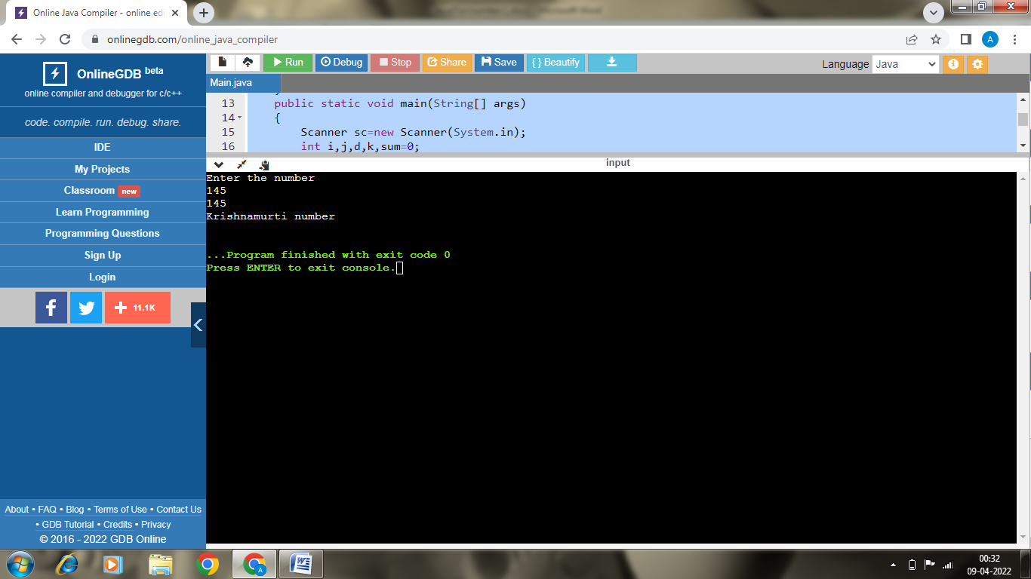

P7

import java.util.\*;

public class Main

{

public static int prime(int x)

{

int d=1;

for(int i=2;i<=x-1;i++)

{

if(x%i==0)

{

d=0;

}

}

return d;

}

public static void main(String[] args)

{

Scanner sc=new Scanner(System.in);

int i,j,d,k,r=0;

System.out.println("Enter the number");

int n=sc.nextInt();

for(i=n;i>0;i=i/10)

{

d=i%10;

r=r\*10+d;

}

if(prime(n)==1 && prime(r)==1)

{

System.out.println("Emirp number");

}

else

{

System.out.println("Not an Emirp number");

}

}

}

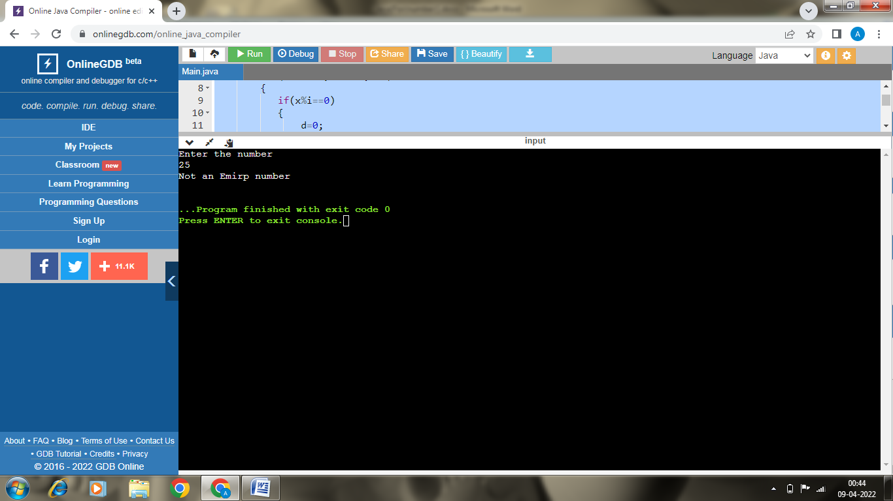

P8

import java.util.\*;

public class Main

{

public static void main(String[] args)

{

Scanner sc=new Scanner(System.in);

int i,j,d,k,r=0;

System.out.println("Enter the number");

int n=sc.nextInt();

for(i=n;i>0;i=i/10)

{

d=i%10;

r=r\*10+d;

}

if(r==n)

{

System.out.println("Palindrome number");

}

else

{

System.out.println("Not an Palindrome number");

}

}

}

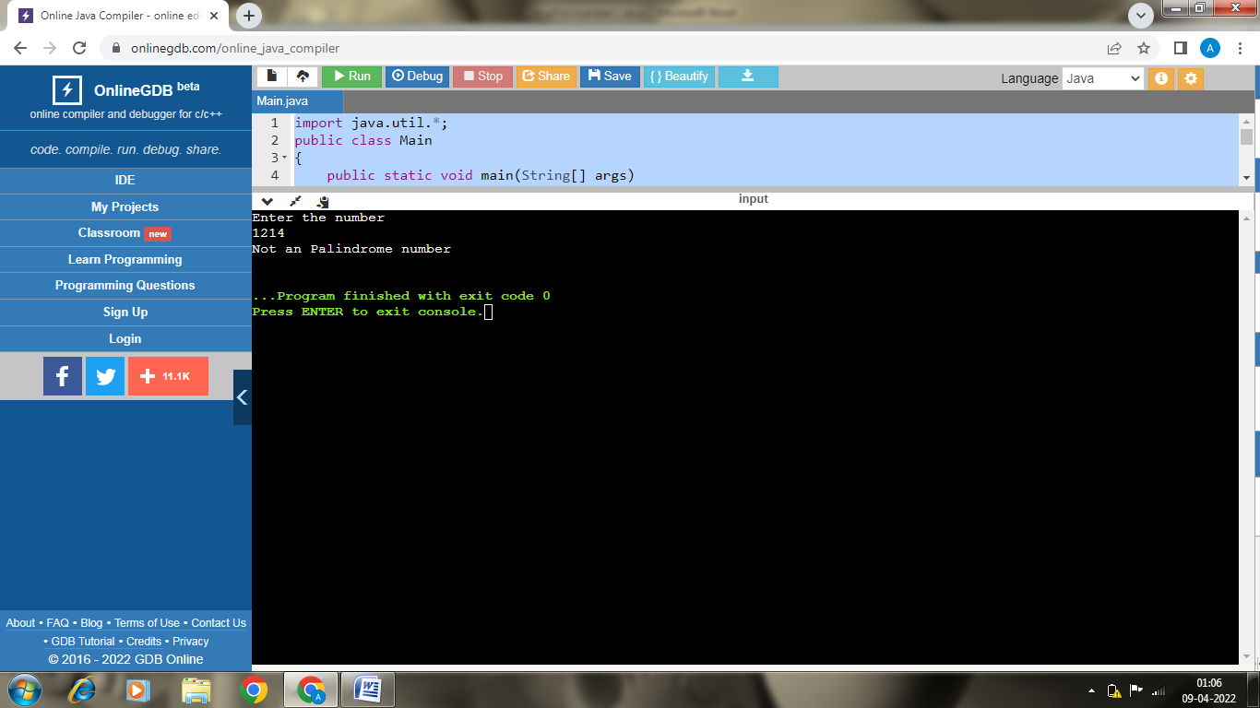

P14

import java.util.\*;

public class Main

{

public static int dig(int y)

{

int i,j,d,sum=0;

for(i=y;i>0;i=i/10)

{

d=i%10;

sum=sum+d;

}

return sum;

}

public static int primefact(int x)

{

int i,j,sum=0;

for(i=2;i<=x;)//for(;n>1;)

{

if(x%i==0)

{

sum=sum+dig(i);

x=x/i;

}

else

{

i+=1;

}

}

return sum;

}

public static void main(String[] args)

{

Scanner sc=new Scanner(System.in);

int i,j,d,k,sum=0;

System.out.println("Enter the number");

int n=sc.nextInt();

for(i=n;i>0;i=i/10)

{

d=i%10;

sum=sum+d;

}

System.out.println(primefact(n));

if(sum==primefact(n))

{

System.out.println("Smith number");

}

else

{

System.out.println("Not a Smith number");

}

}

}

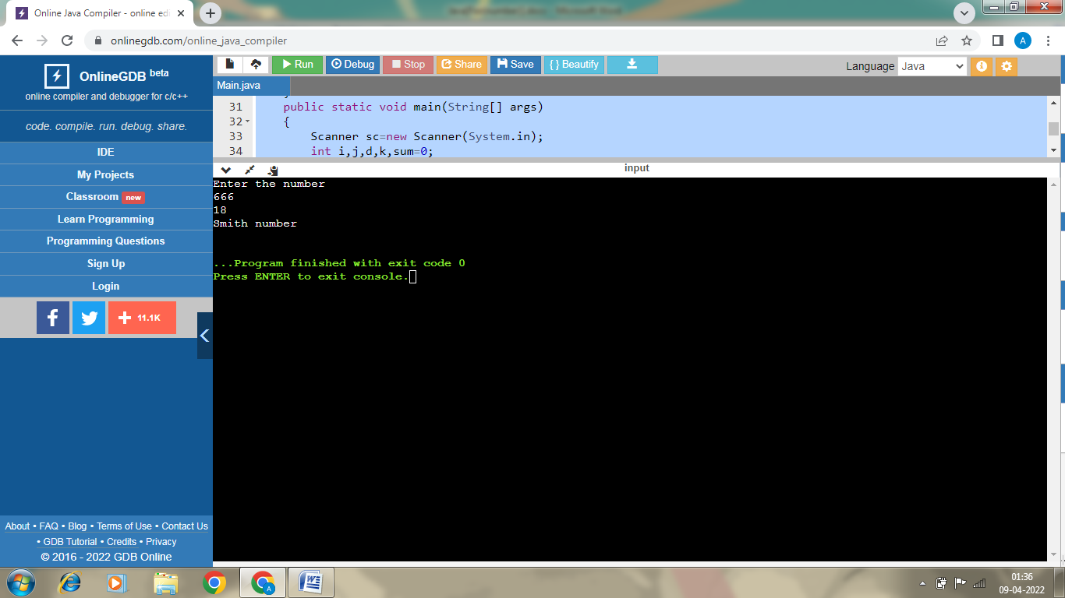

P10

import java.util.\*;

public class Main

{

public static void main(String[] args)

{

Scanner sc=new Scanner(System.in);

int d,sum=0;

int pr=1;

System.out.println("Enter number");

int n=sc.nextInt();

d=n;

while(d>0)

{

sum=sum+(d%10);

d=d/10;

}

for(int i=n;i>0;i=i/10)

{

pr=pr\*(i%10);

}

System.out.println(pr);

System.out.println(sum);

if(pr==sum)

{

System.out.println("Perfect number");

}

else

{

System.out.println("Not Perfect number");

}

}

}

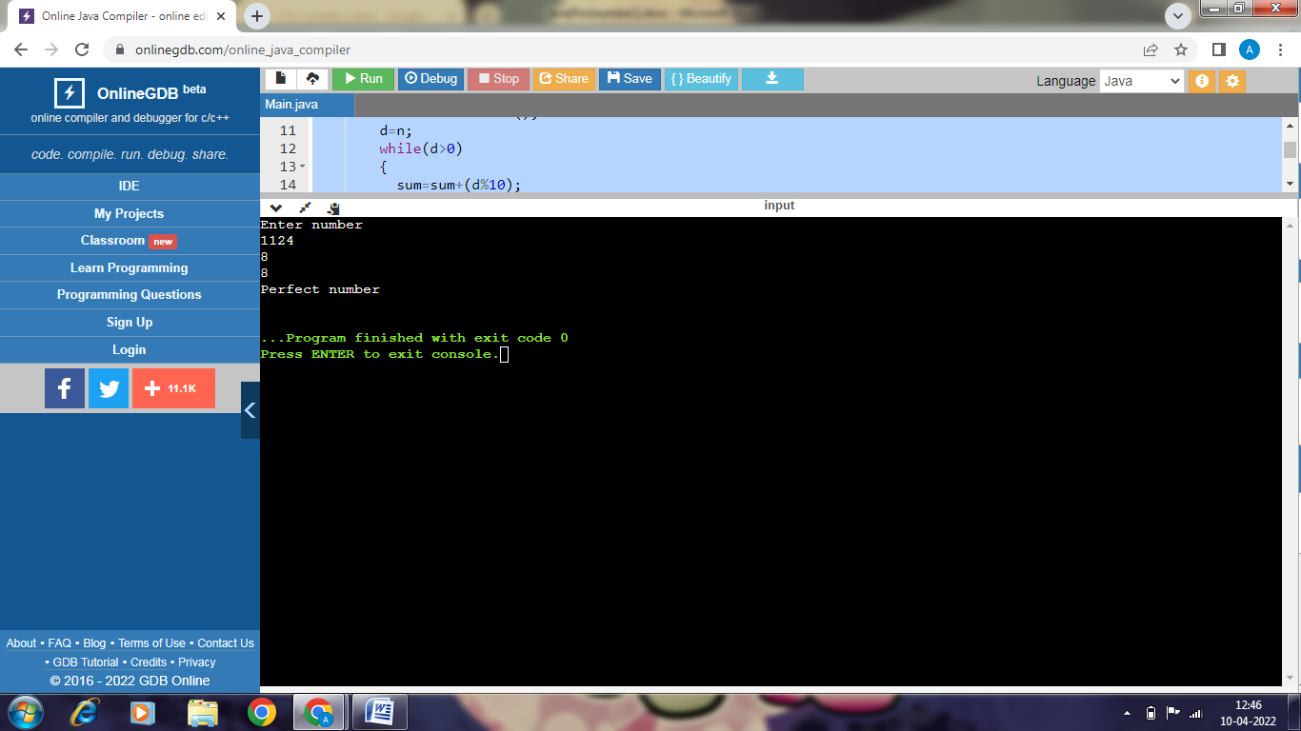

P15

import java.util.\*;

public class Main

{

public static void main(String[] args)

{

Scanner sc=new Scanner(System.in);

int d,sum=0;

int pr=1;

System.out.println("Enter number");

int n=sc.nextInt();

d=n;

while(d>0)

{

sum=sum+(d%10);

d=d/10;

}

if(n%sum==0)

{

System.out.println("Harshad number");

}

else

{

System.out.println("Not Harshad number");

}

}

}

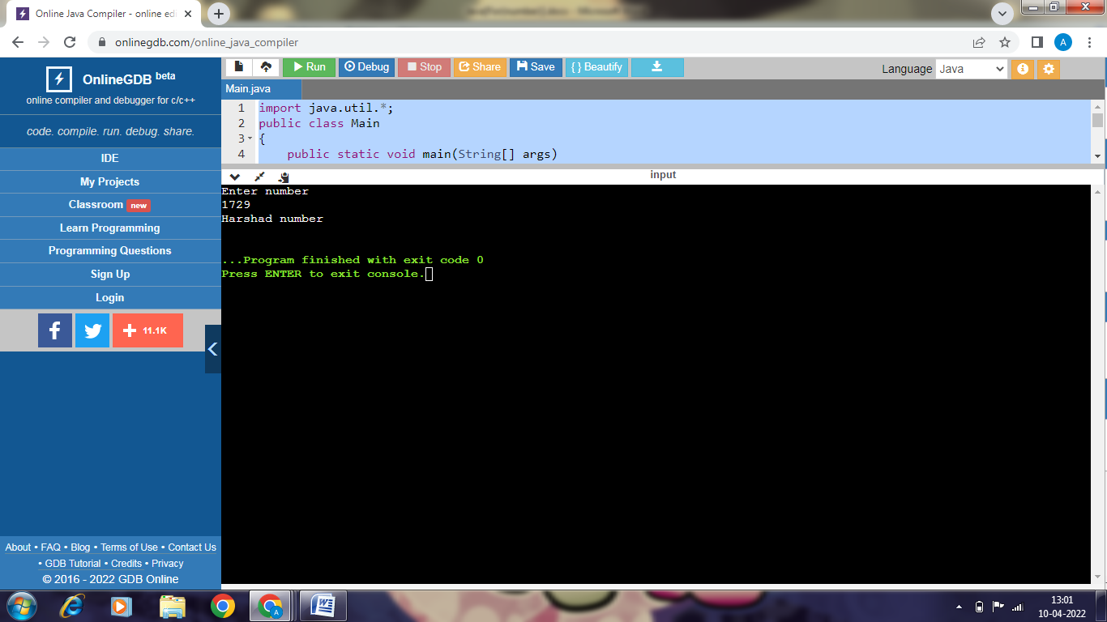

P21

import java.util.\*;

public class Main

{

public static void main(String[] args)

{

Scanner sc=new Scanner(System.in);

int f=0;

System.out.println("Enter number");

int n=sc.nextInt();

if(n%10==7 && (n%7==0))

{

f=1;

}

if(f==1)

{

System.out.println("Buzz number");

}

else

{

System.out.println("Not Buzz number");

}

}

}

